Cllr Robin Bennett, County Councillor Report: June 2024
Robin.bennett@Oxfordshire.gov.uk

Oxfordshire County Council Local Flood Risk Management Strategy
The draft Local Flood Risk Management Strategy (LFRMS) will shortly open for public consultation. It sets out how, in OCC’s role as lead local flood authority for Oxfordshire, the council will work together with partner authorities to manage flood risk. The consultation covers Oxfordshire’s second LFRMS, which will cover a five-year period. In addition, it’s looking at the longer-term consequences that need to be taken into account, particularly in relation to climate change.

What does the strategy do?
It provides an overview of flood risk management across the county, as well as the roles and responsibilities of risk management authorities and other key stakeholders. It also includes information for residents, businesses and developers to help them understand and manage flood risk. Underpinning the strategy are a series of objectives and measures that will be followed to manage and, where possible, reduce flood risk within Oxfordshire.

What's not in the strategy?
The strategy doesn't replicate or replace the National Flood and Coastal Erosion Risk Management Strategy prepared by the Environment Agency.

It's not designed to be guidance on how authorities should respond in an emergency or incident related to flooding. These are still covered by the local resilience forums and multi-agency approaches under the Civil Contingencies Act.
Lastly, it doesn't allocate land for new developments or local planning policies. The
evidence base for planning decisions in relation to flood risk sits within the strategic flood risk assessment prepared by the local planning authority.

Timeline
The consultation is expected to run rom the 21 June for eight weeks on
Let's talk Oxfordshire. It will include the draft strategy and action plan, as well as an online questionnaire to gather comments and thoughts.
If you have any queries or questions, please email floodmanagement@oxfordshire.gov.uk.

Former energy minister visits to discuss challenges and opportunities of net zero

The man who signed the UK’s commitment to net zero into law in 2019 visited OCC to meet with our senior leaders to talk about how to take our climate
programme to the next level.

Former Energy and Clean Growth Minister, Chris Skidmore, who resigned as an MP in February over his government’s approval of new fossil fuel extraction, attended the round table event at County Hall, organised by Councillor Dr Pete Sudbury (Deputy Leader) who has cabinet responsibility at OCC for climate change, environment and future generations.

Oxfordshire’s libraries in numbers (more than just books!)
Check out this infographic from our library services to celebrate their performance highlights for 2023/24. It really illustrates how our libraries provide a vital link with all our communities.
More people are visiting our libraries and, fresh from Mental Health Awareness Week last week, it's great to see so many conversations around mental health and wellbeing (up 18.5 per cent on last year).
Don't forget, our library service sends out monthly newsletters – subscribe at https://www.oxfordshire.gov.uk/residents/libraries
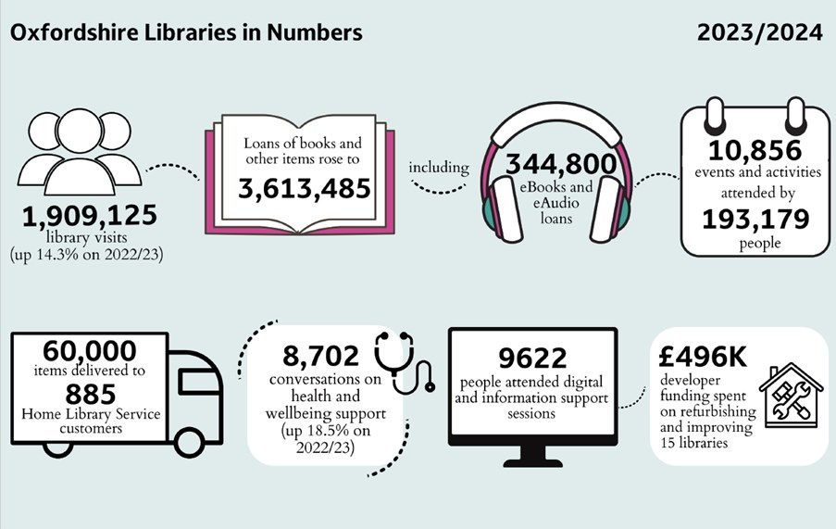

Making mental health care better.
People who have accessed adult mental health services are being asked to help us make mental health care better in the county.
OCC are working together with doctors, voluntary groups, community services and others to help everyone in Oxfordshire with their mental health. Feedback will be used to help the council make decisions about future services. The survey will be open until midnight on 15 July 2024.
https://letstalk.oxfordshire.gov.uk/mental-health-survey

